The report of mini-project N1 program
by Ulvi Bajarani
SID 20539914

All retrieved results and processings are saved in two different log files created by the program (if the log files don’t exist, the program creates it. Otherwise, it appends): logFile.txt and ResultslogFile.txt

The program processes not only 50 images, but also 1, 10, 20, 30 images chosen randomly. The .py file could be found in /python folder. The image processing results are saved in the /resultsOfProcessing folder. Separate folders for separate processes are created by the program. The program processes 50 images, so the dataset should be at least with 50 images. All images must be in the /imagesToProcess folder located in the same folder with the /python folder. The /python folder contains the code files. In other words, /imagesToProcess folder must be one level up than the code file.

The time measures are calculated by the time.process_time() function (start_time and stop_time variables), which returns the sum of the user and system CPU time of the running process. The start_time and stop_time variables exist in all processing functions. Below you can the execution results:

Point Operation Comparison on the grayscale version of image set (in seconds)

No of images | Thresholding |  | Negative image |  | Log transform (c=108.5)
 | Formula | LUT | Formula | LUT | Formula | LUT
1* | 4.40625 | 1.15625 | 5.640625 | 1.140625 | 7.0 | 1.1875
10* | 38.421875 | 10.390625 | 47.375 | 10.875 | 63.03125 | 11.109375
20* | 97.84375 | 26.65625 | 120.765625 | 26.921875 | 155.765625 | 27.5
30* | 157.734375 | 42.25 | 216.59375 | 43.46875 | 266.296875 | 43.90625
50 | 247.578125 | 70.84375 | 315.9375 | 70.671875 | 403.875 | 69.859375

*-the results vary, since the picture set processed by the program is generated randomly.
The program describes the actual state of processing. In the screenshots below, it might be seen the first seconds of the program that had already finished grayscale transformation, but not finished thresholding by LUT yet:
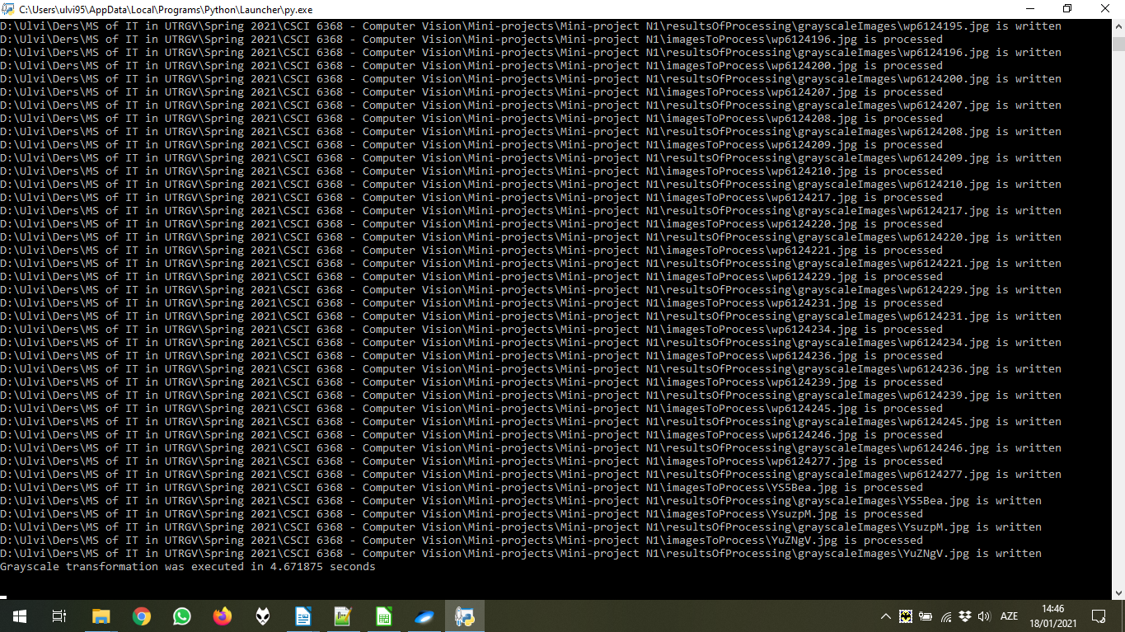

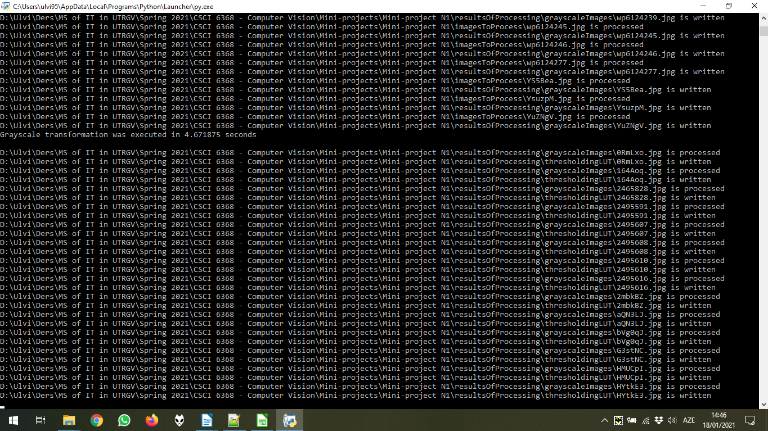
The processing is done for 50 images. Below the thumbnails of results of processing for 10 images (out of 50) chosen randomly. As mentioned above, all results could be found in the /resultsOfProcessing folder.

Point Operation Comparison on the grayscale version of sample image

Sample Image | Thresholding | Negative Image | Log Transform (c=108.5)
 | 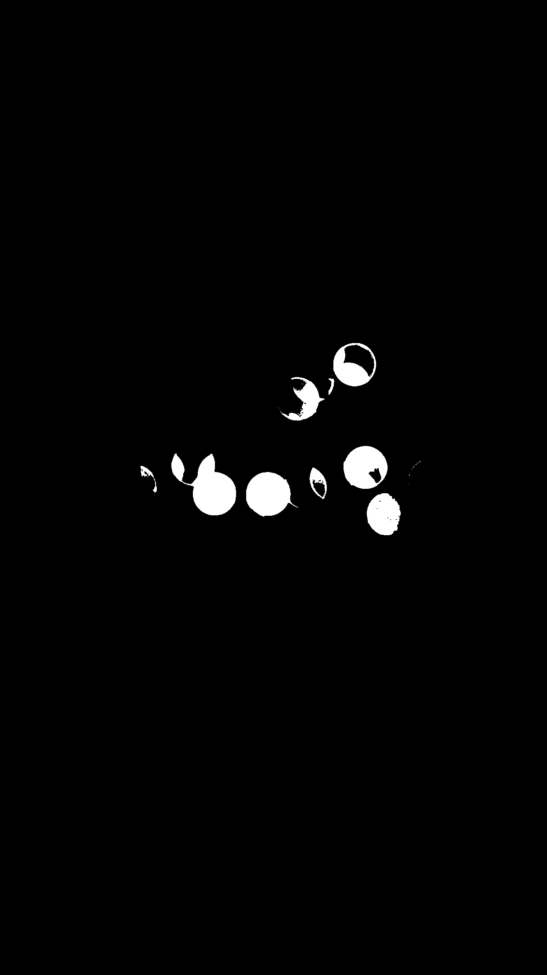 |  | 
 |  | 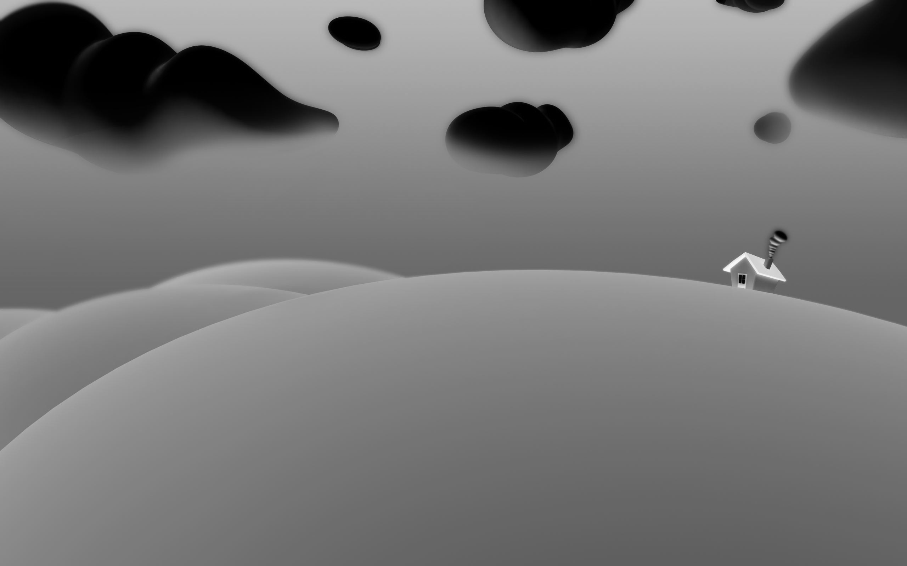 | 
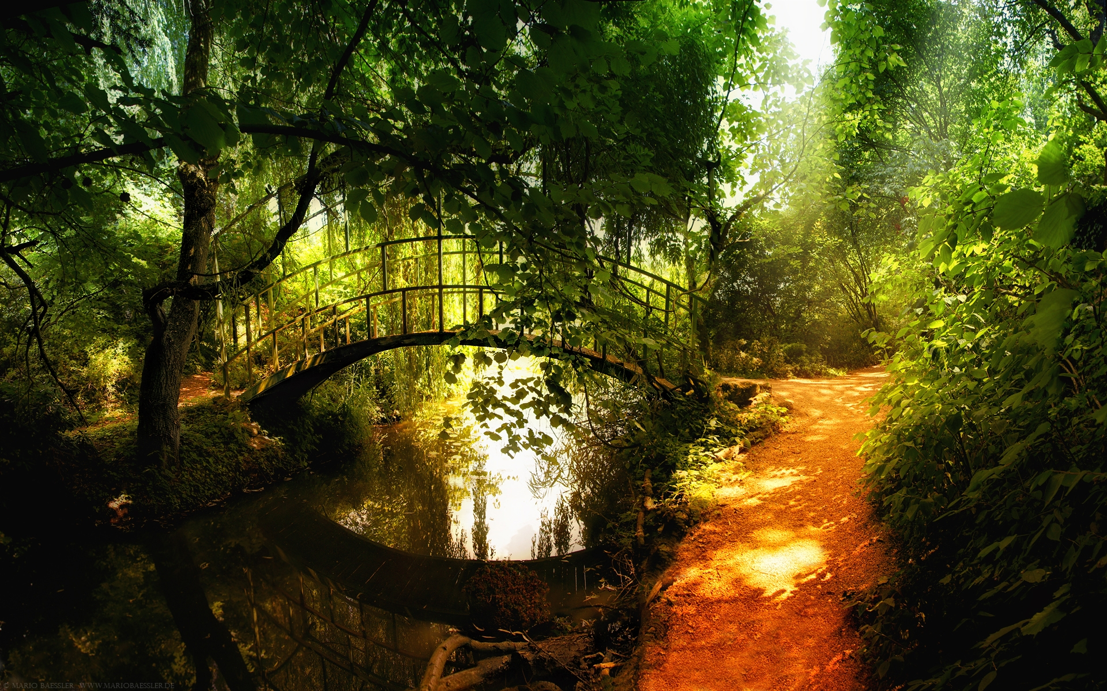 | 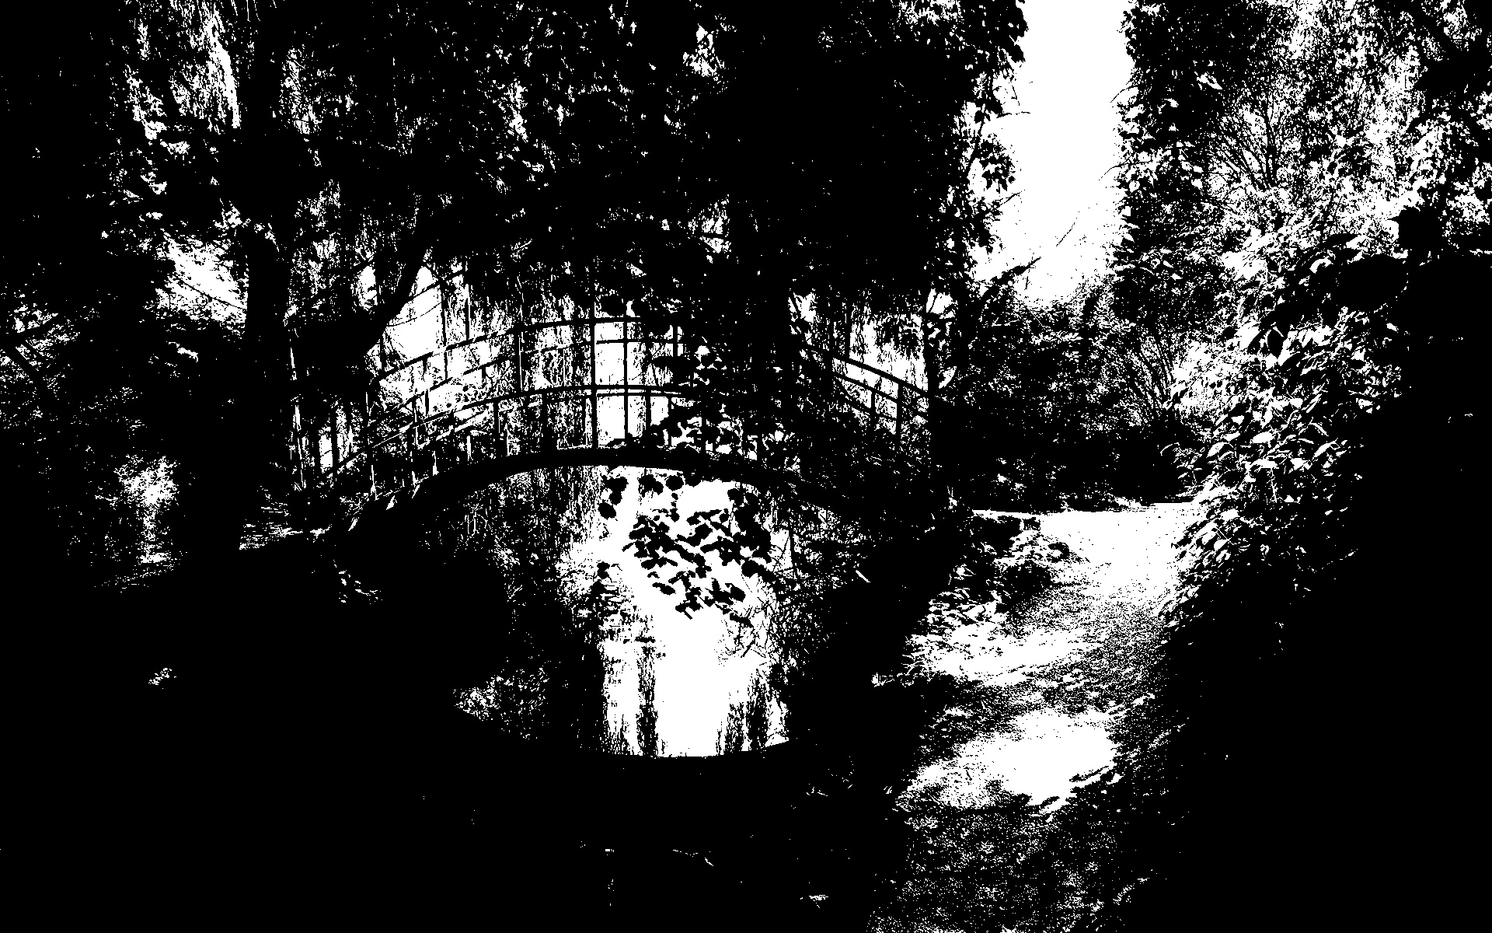 | 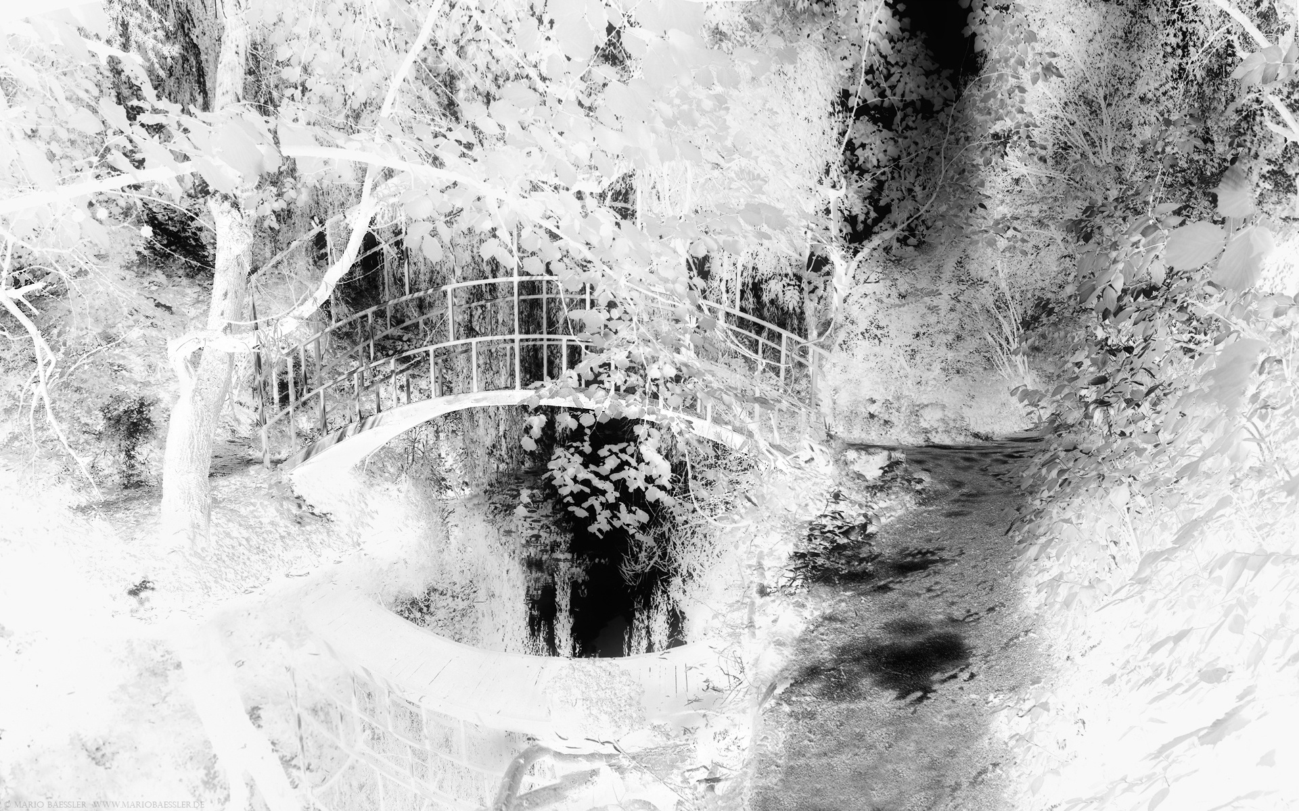 | 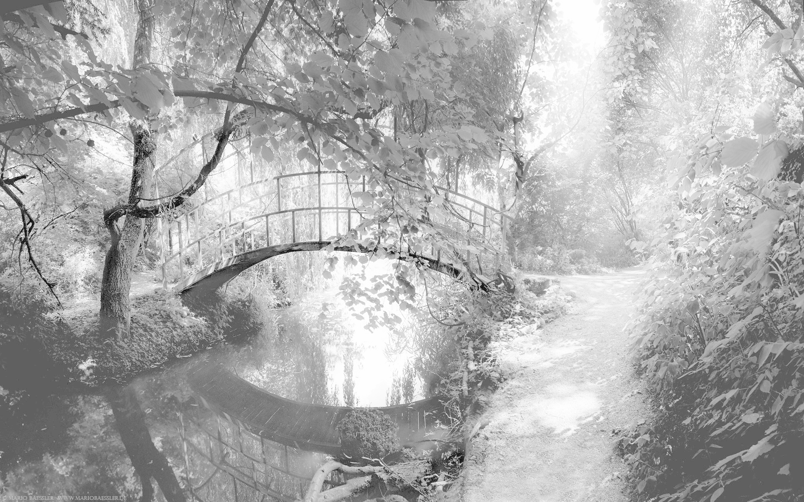
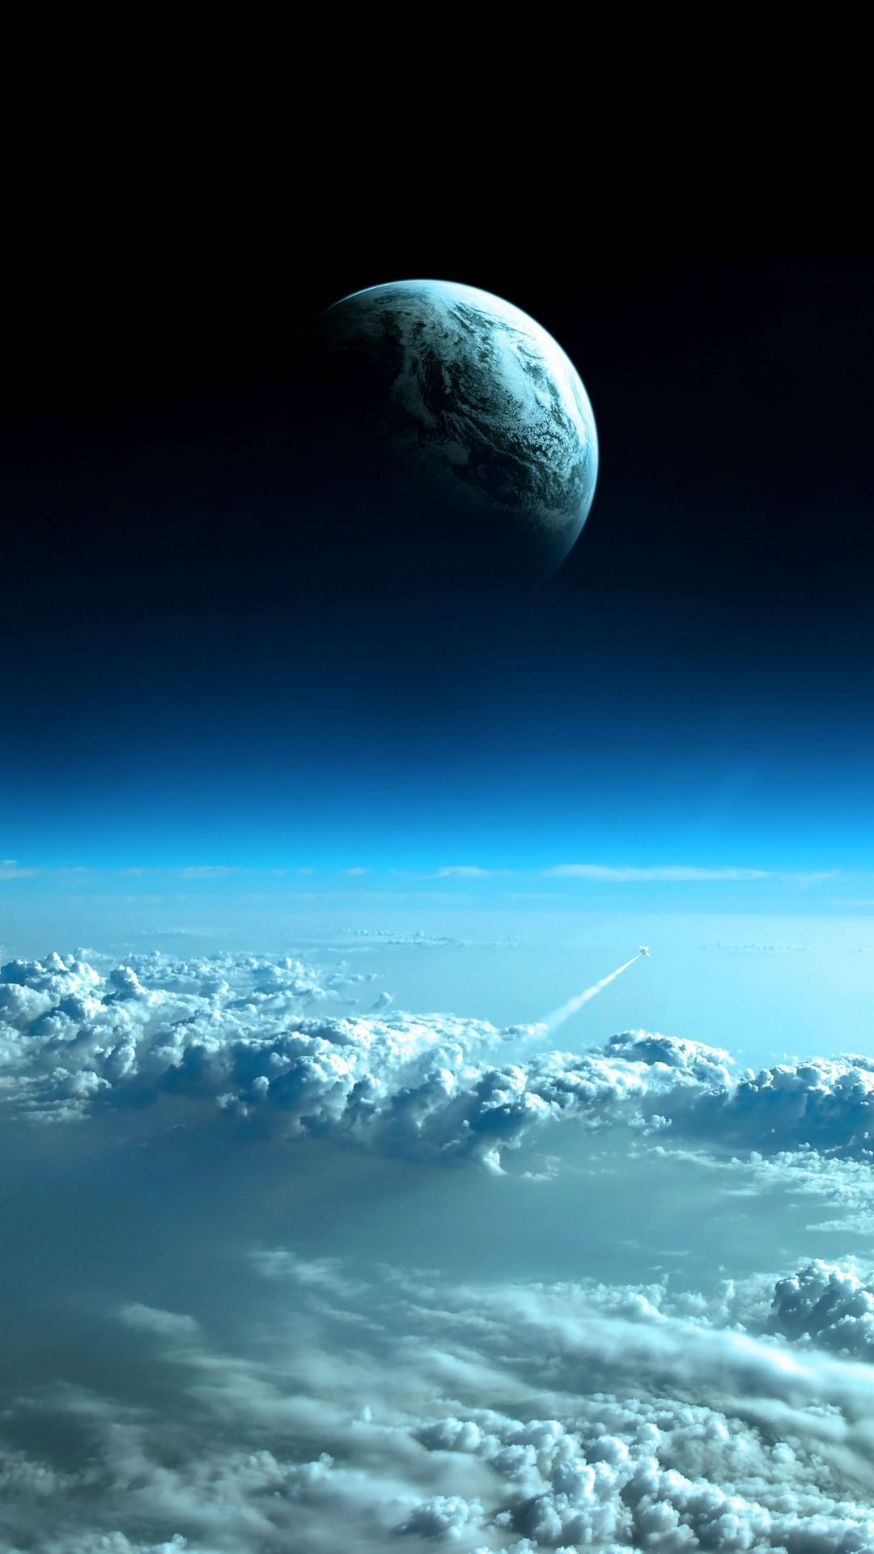 | 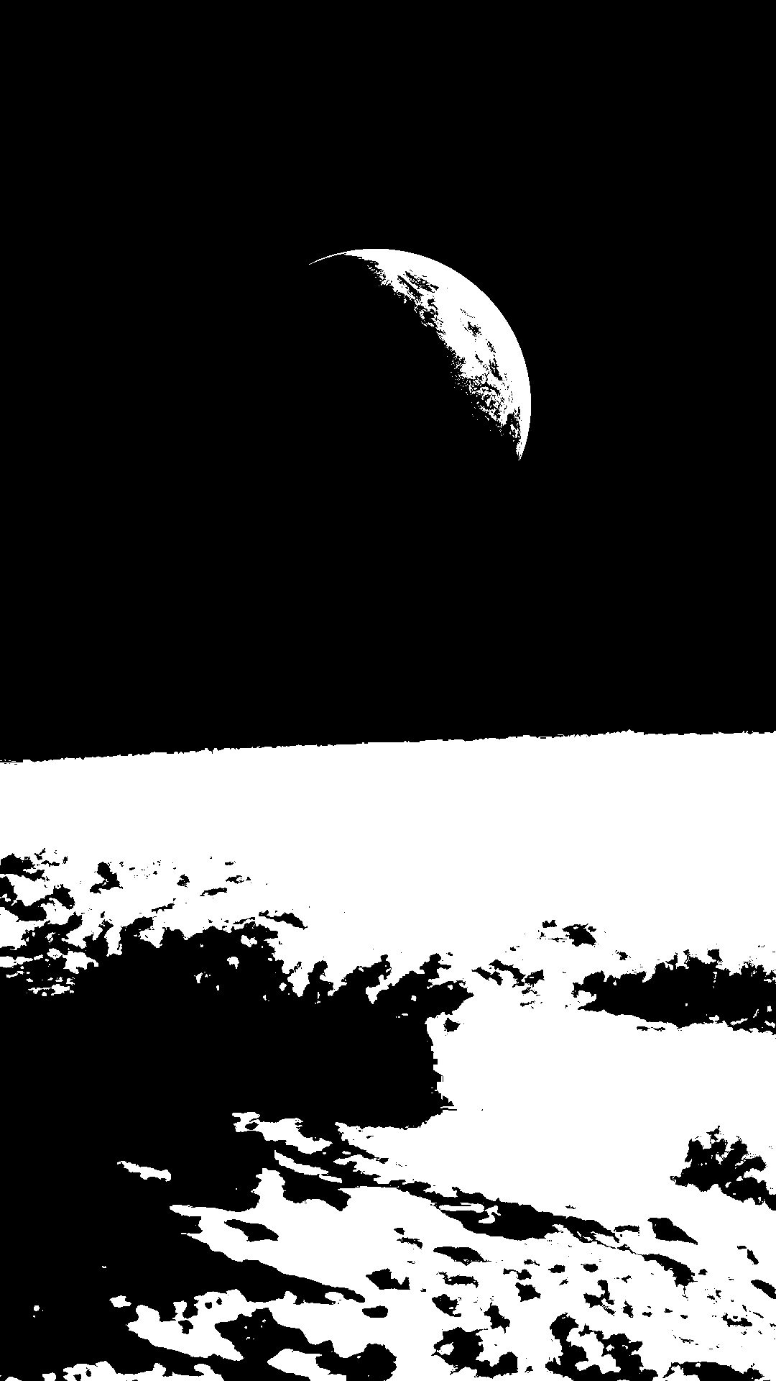 | 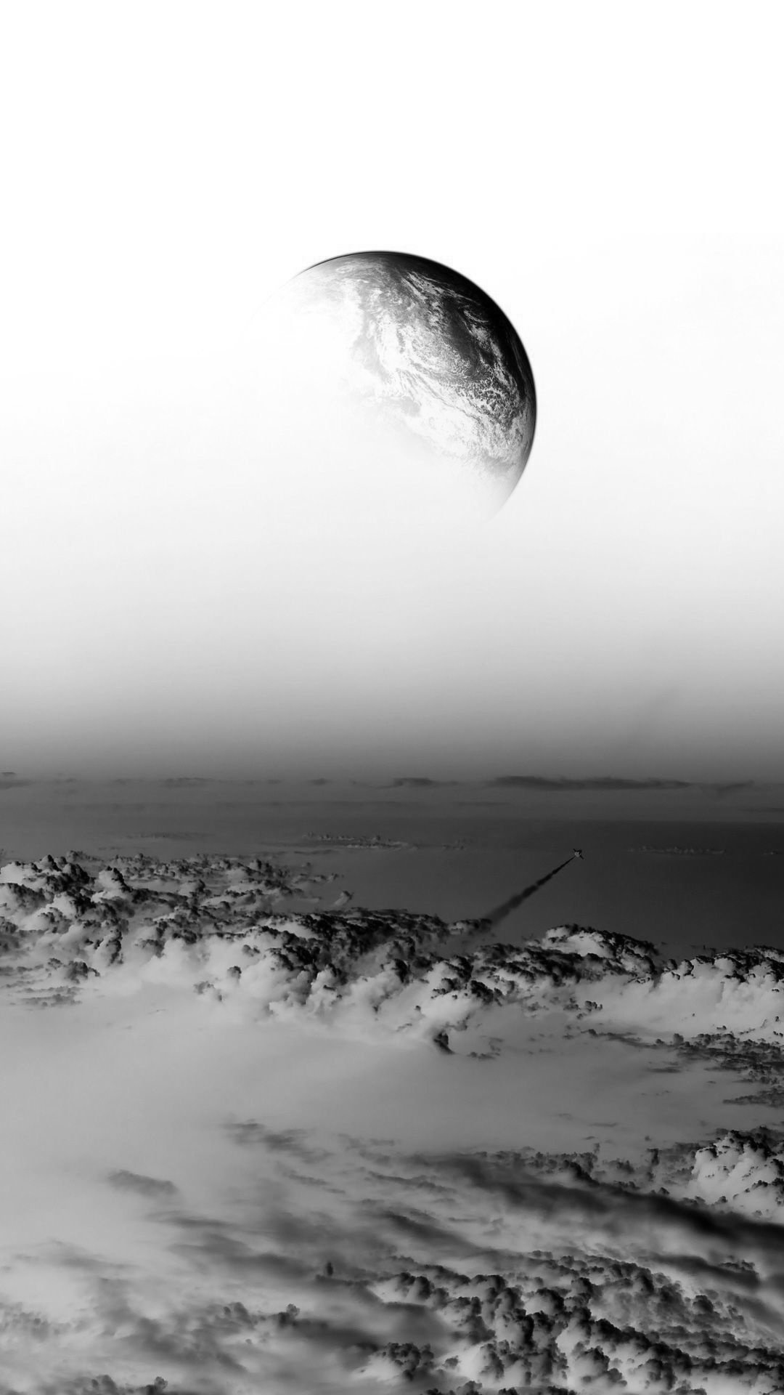 | 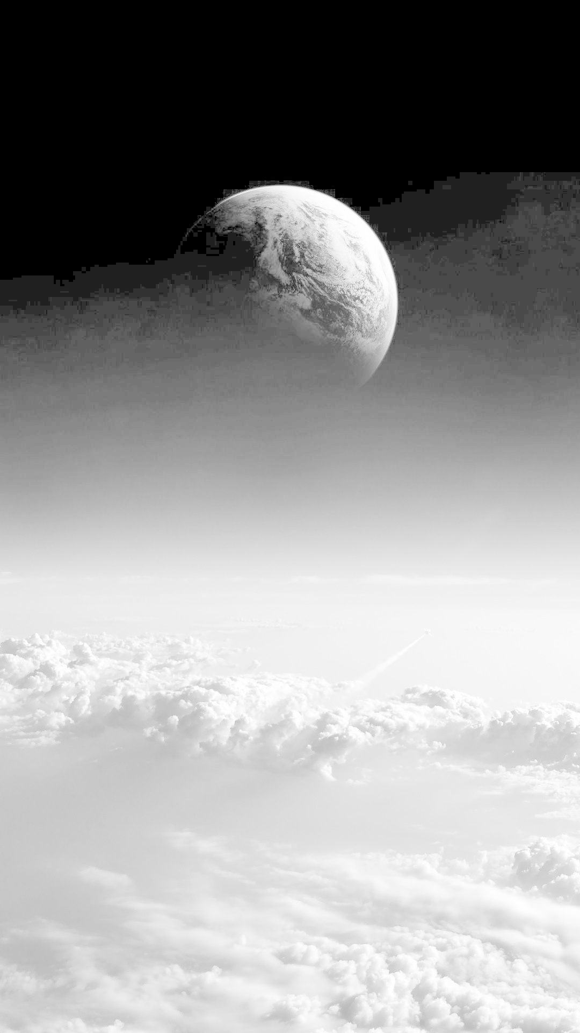

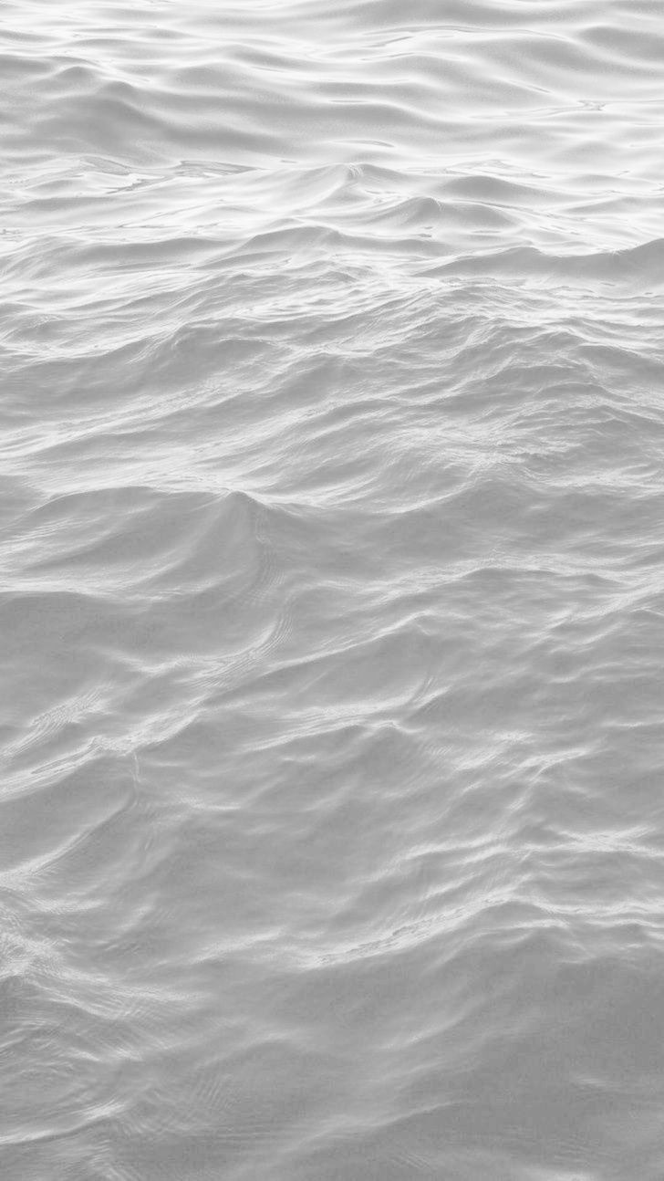
Point Operation Comparison on the grayscale version of sample image

Sample Image | Thresholding | Negative Image | Log Transform (c=108.5)
 | 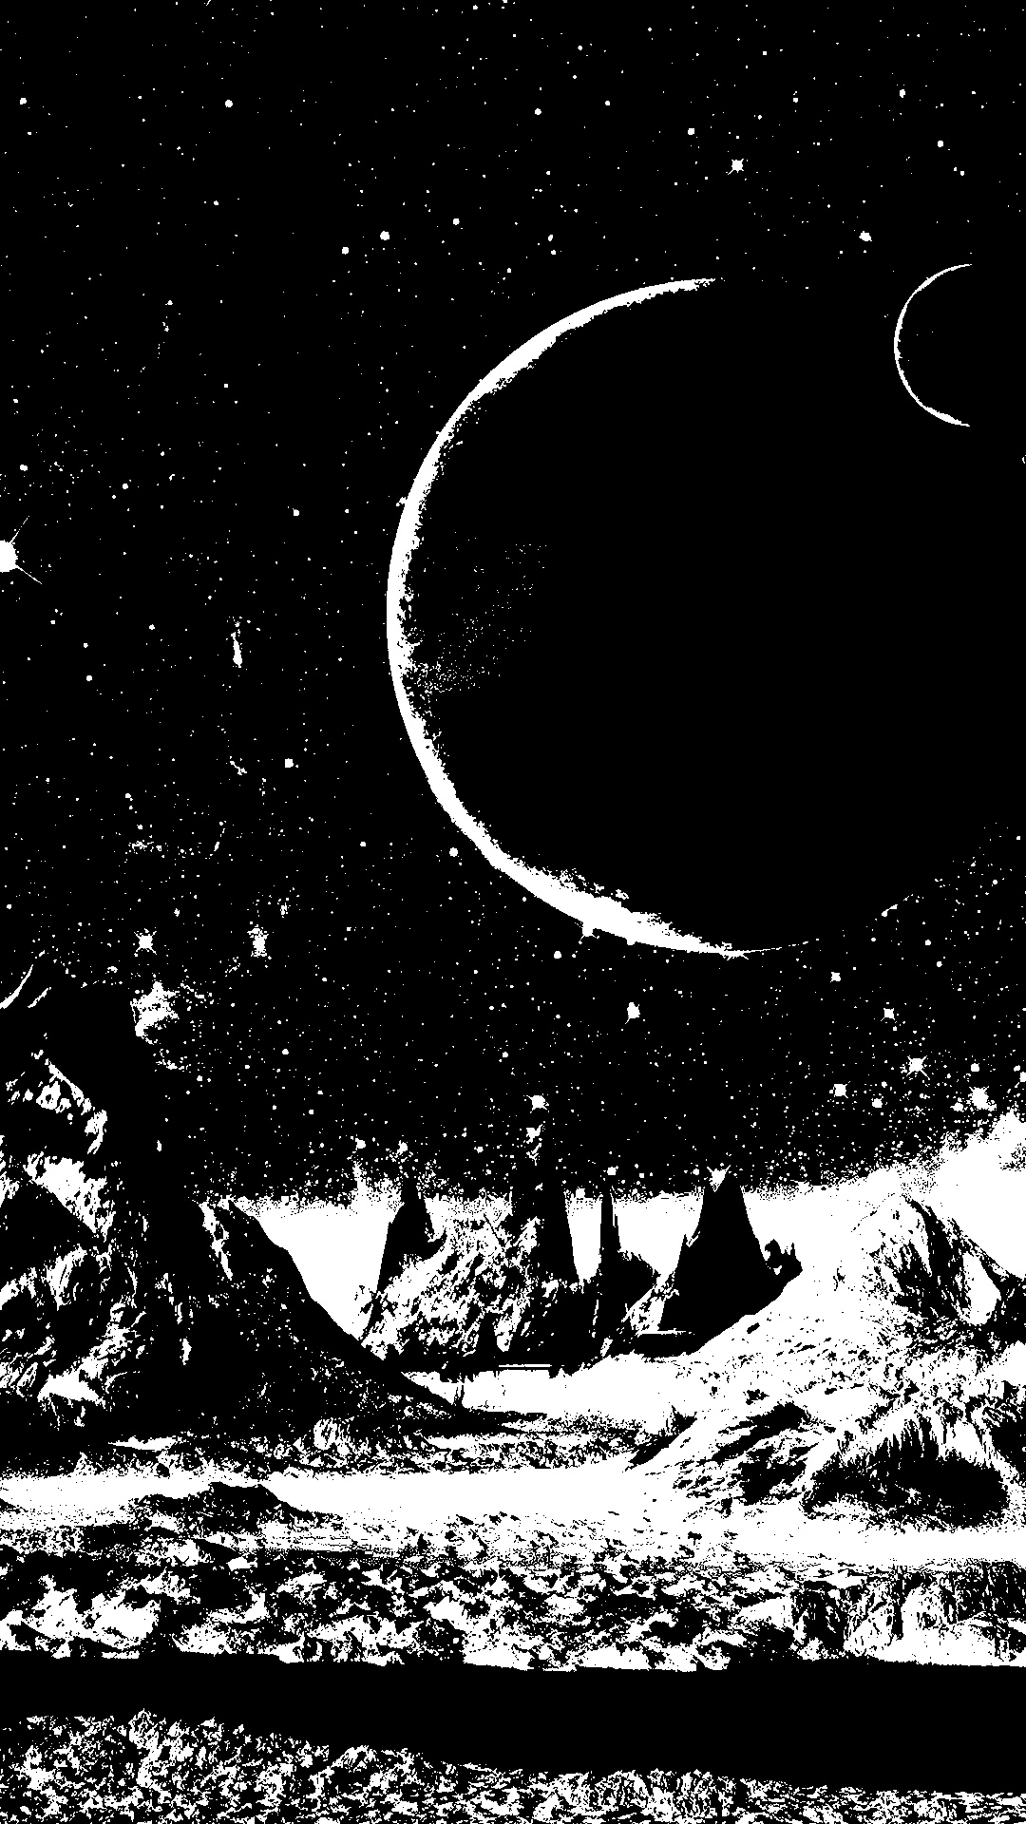 | 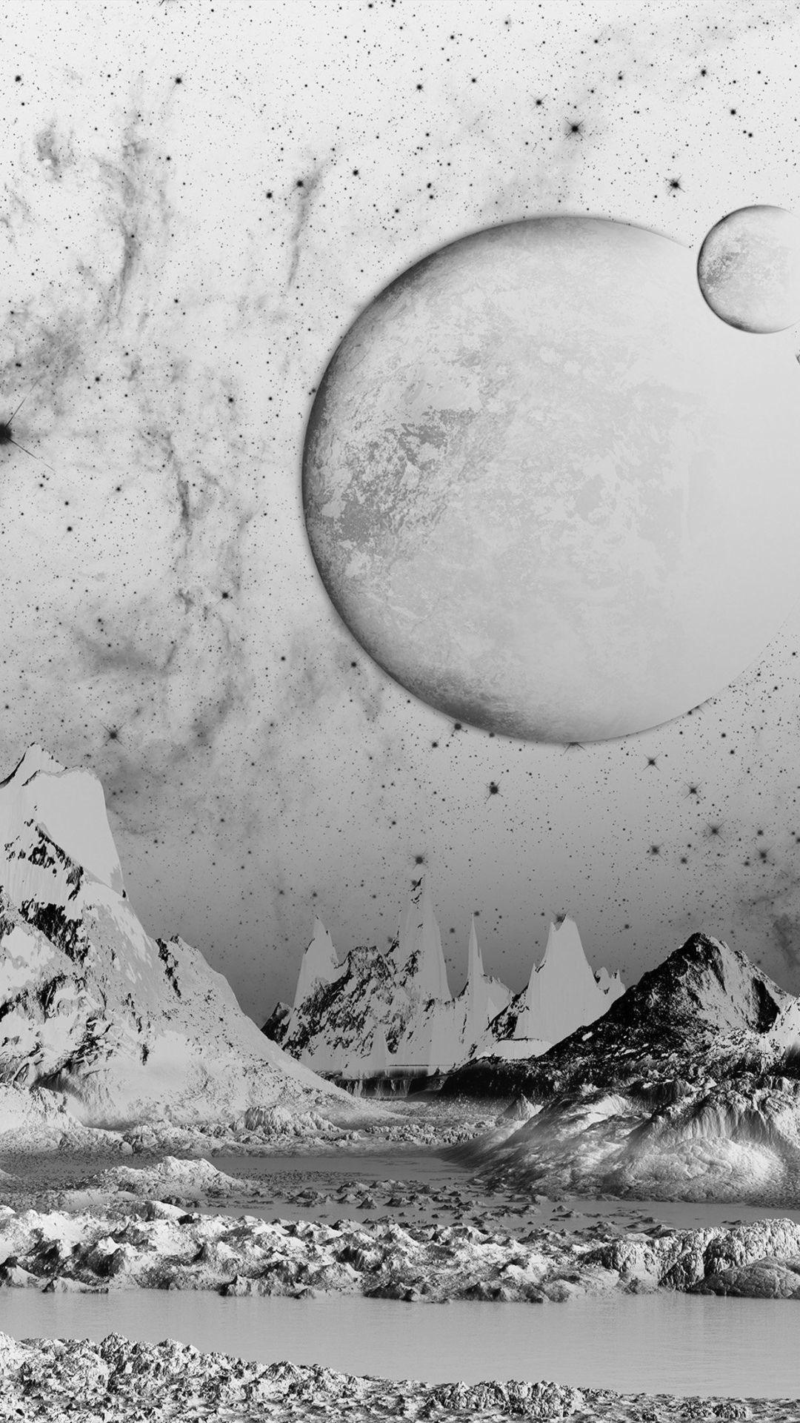 | 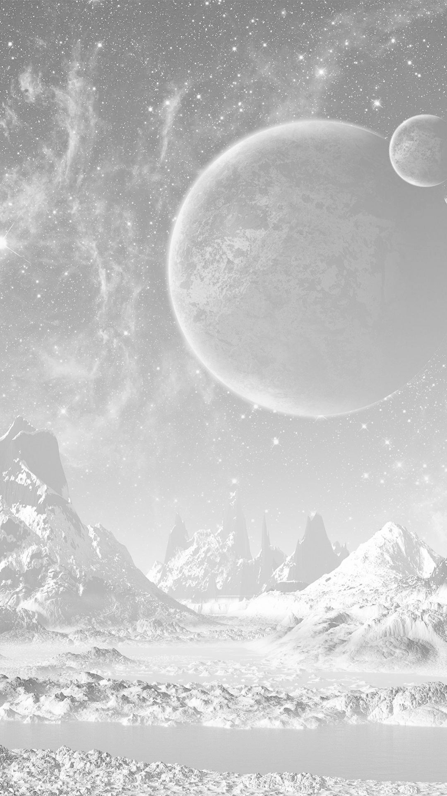
 |  | 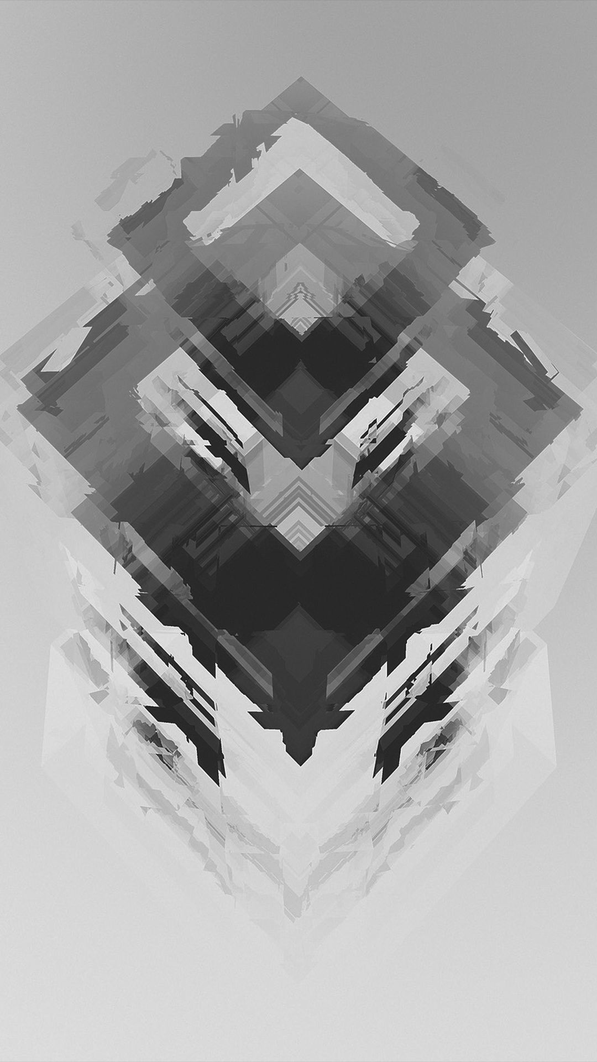 | 
 |  | 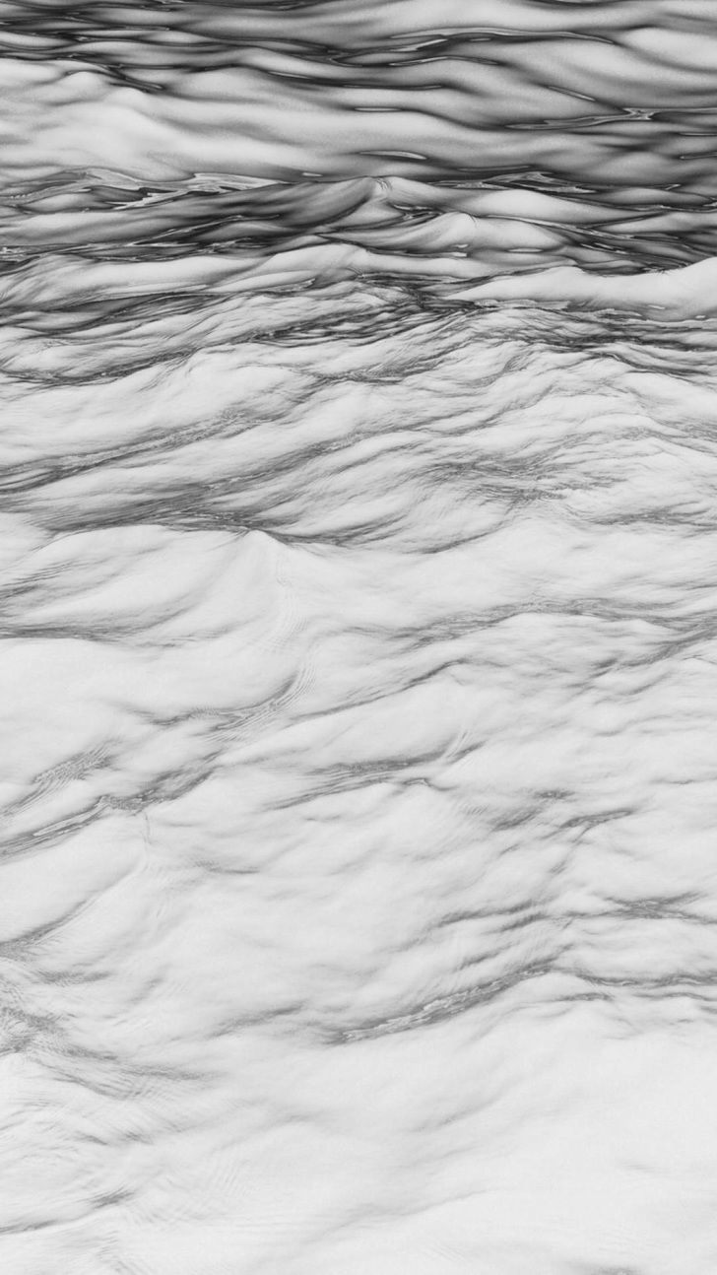

Point Operation Comparison on the grayscale version of sample image

Sample Image | Thresholding | Negative Image | Log Transform (c=108.5)
 | 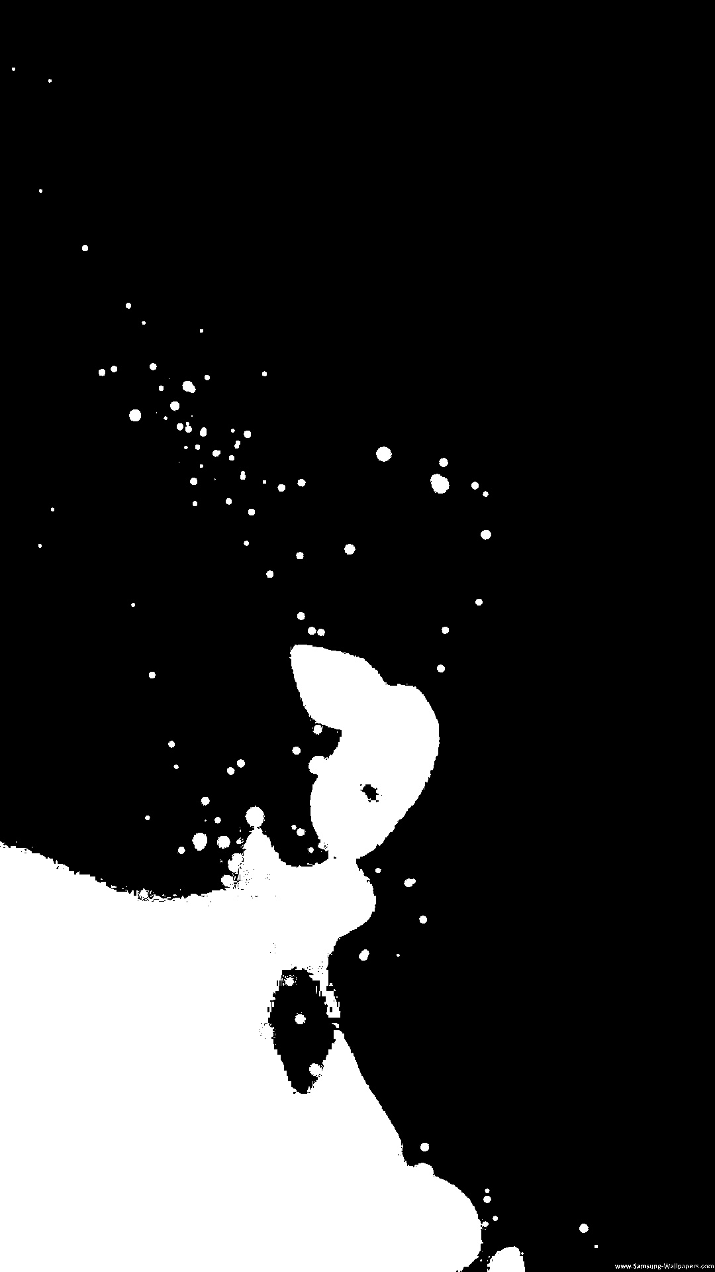 | 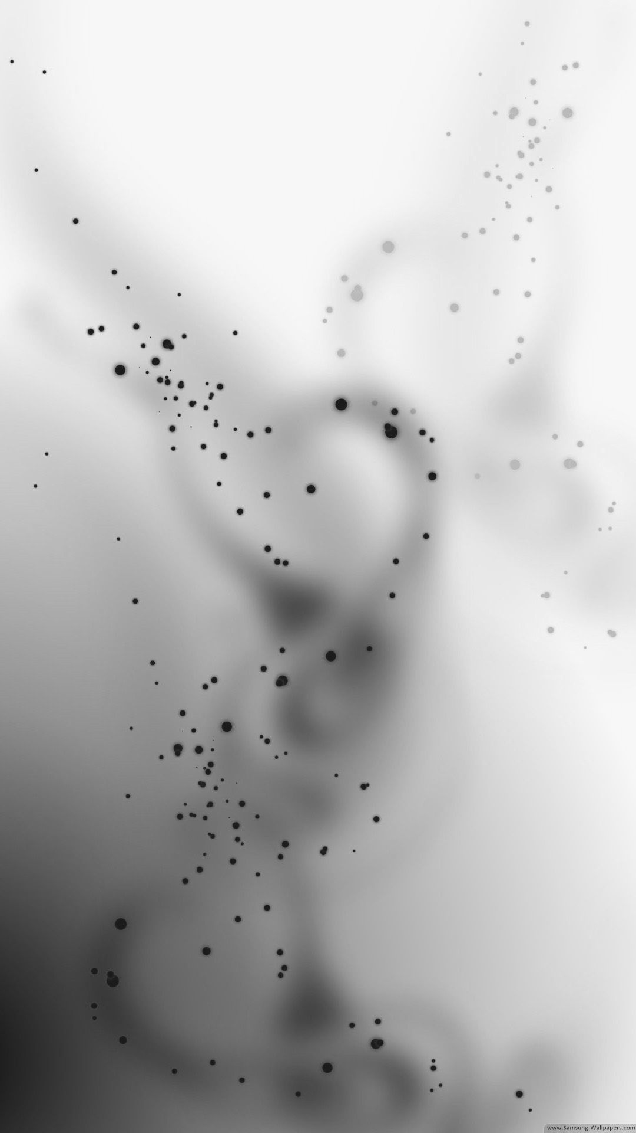 | 
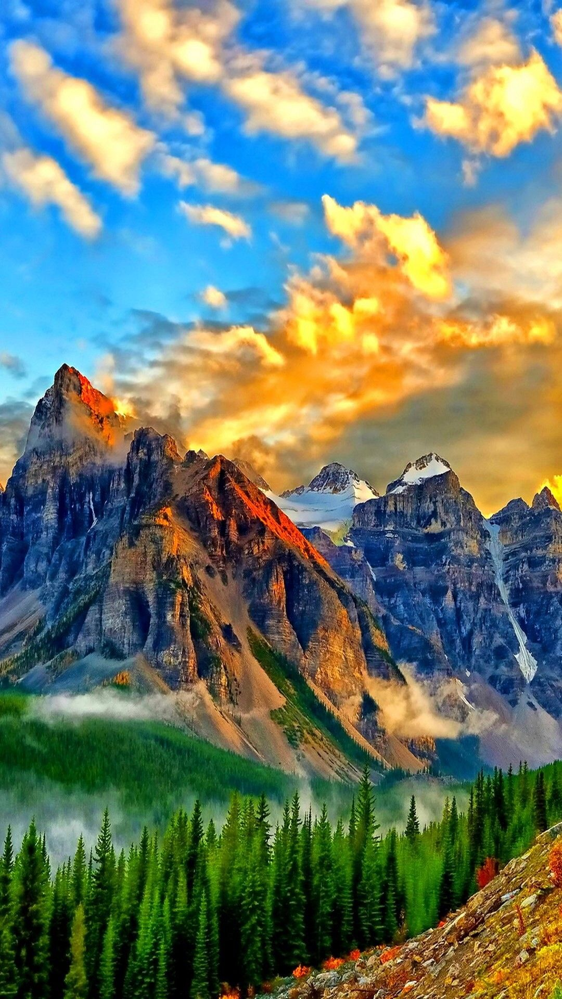 | 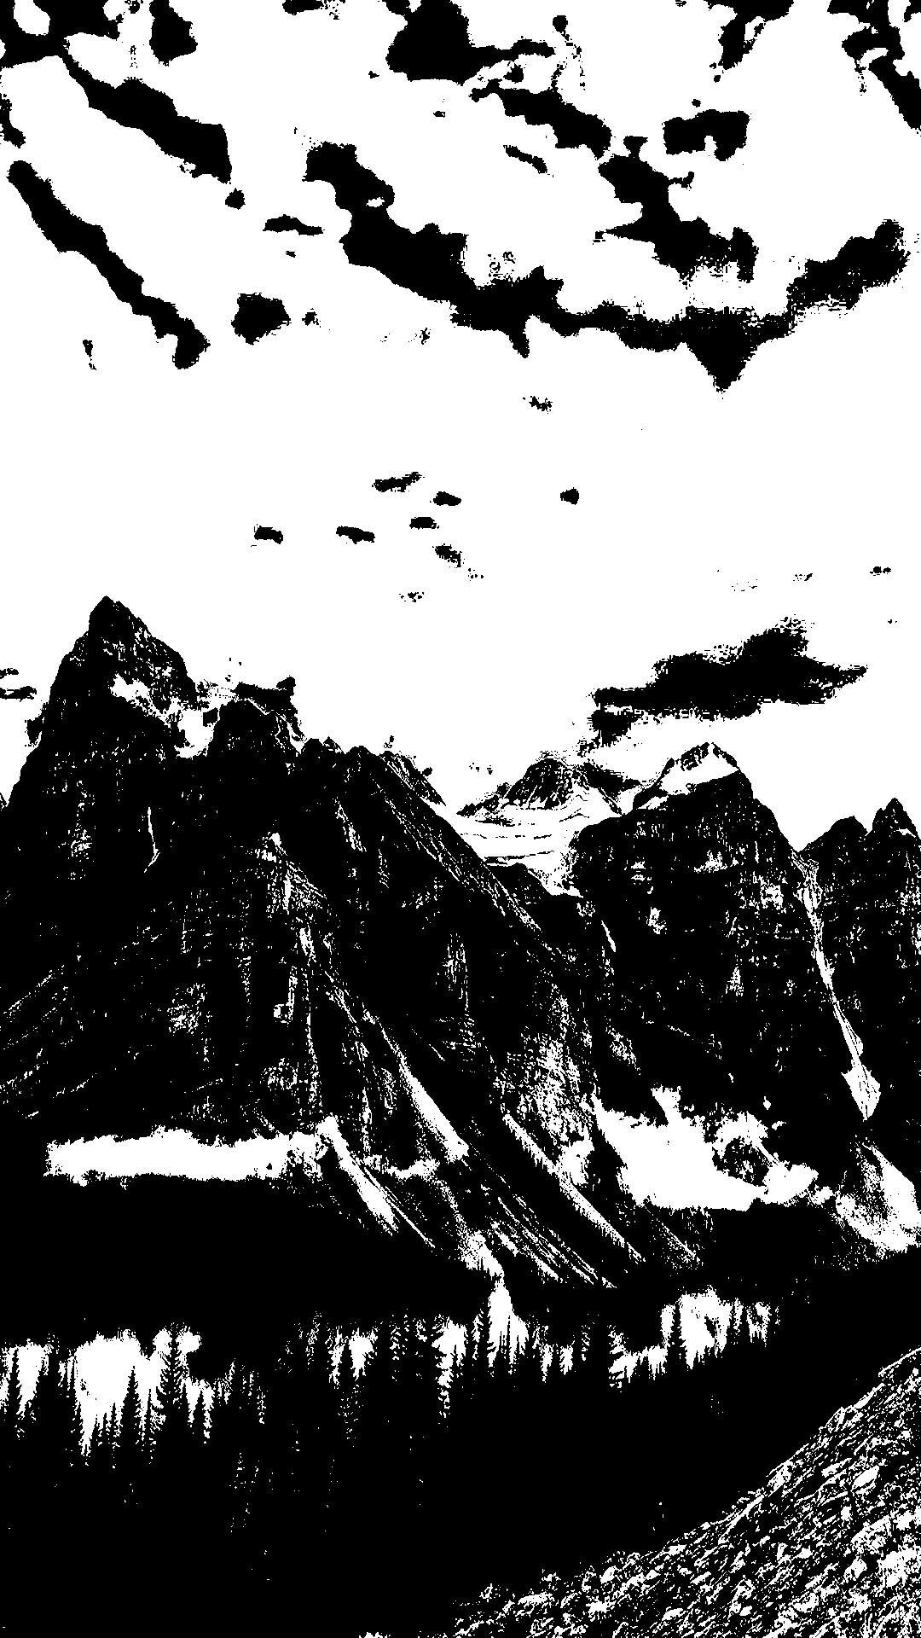 | 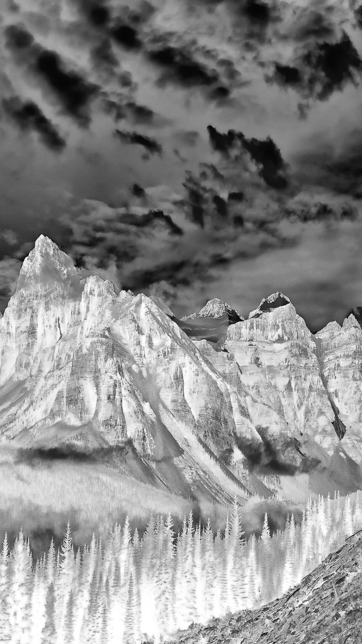 | 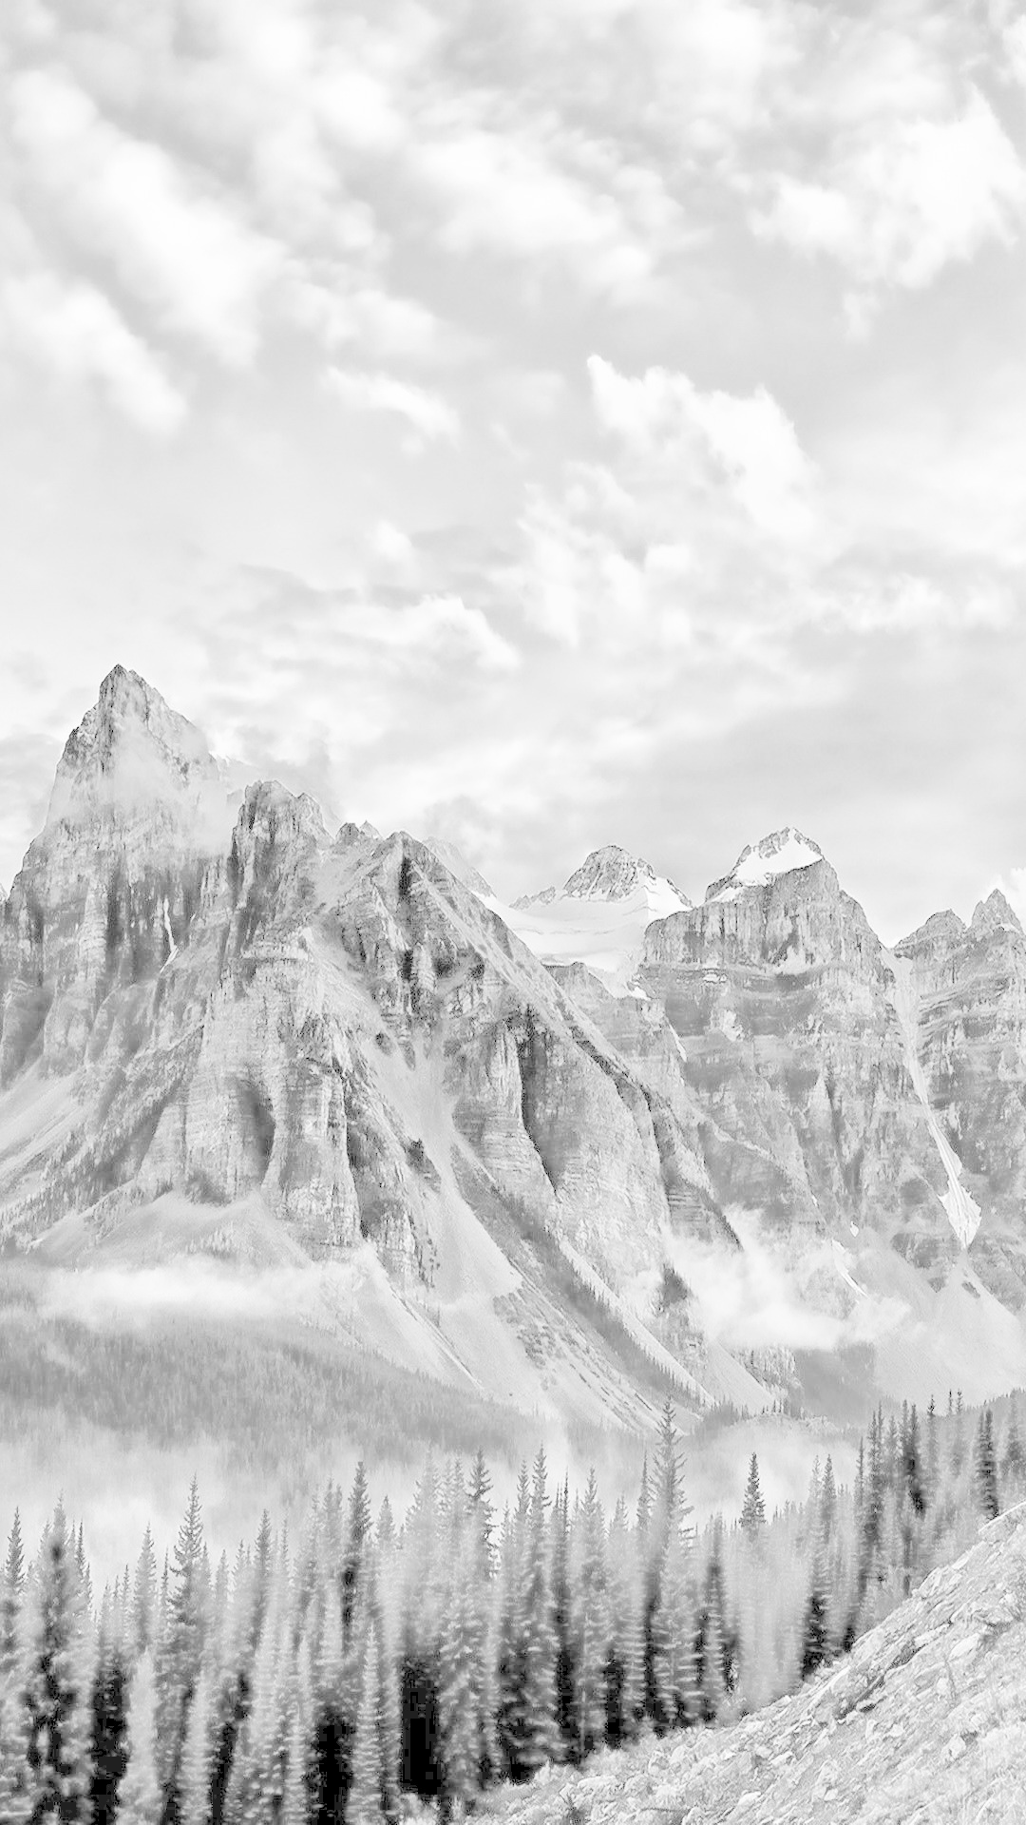
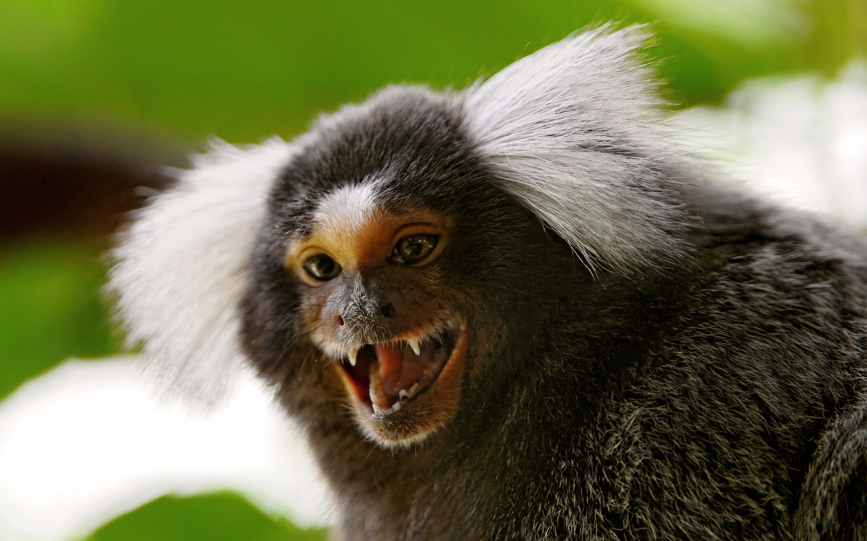 | 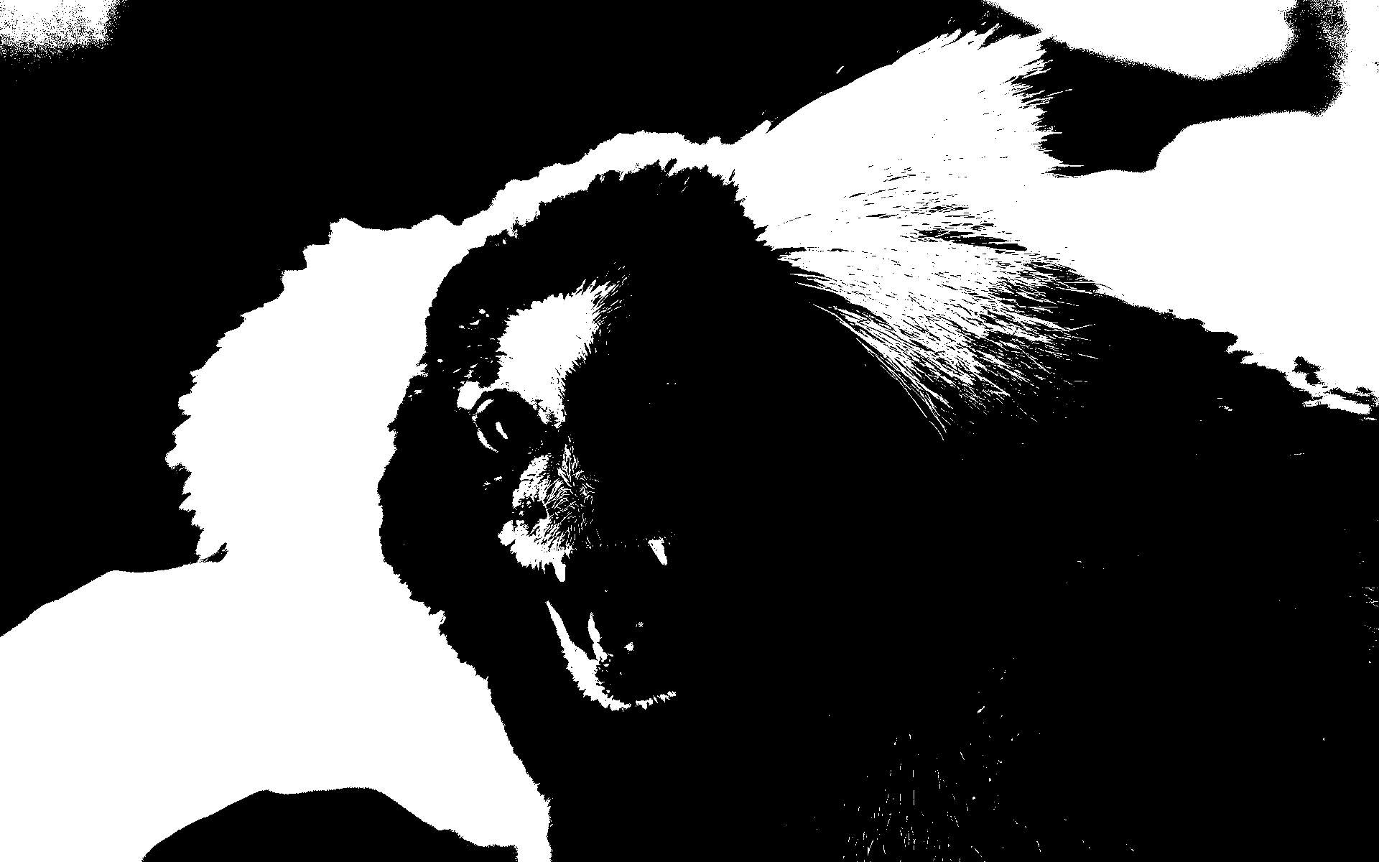 | 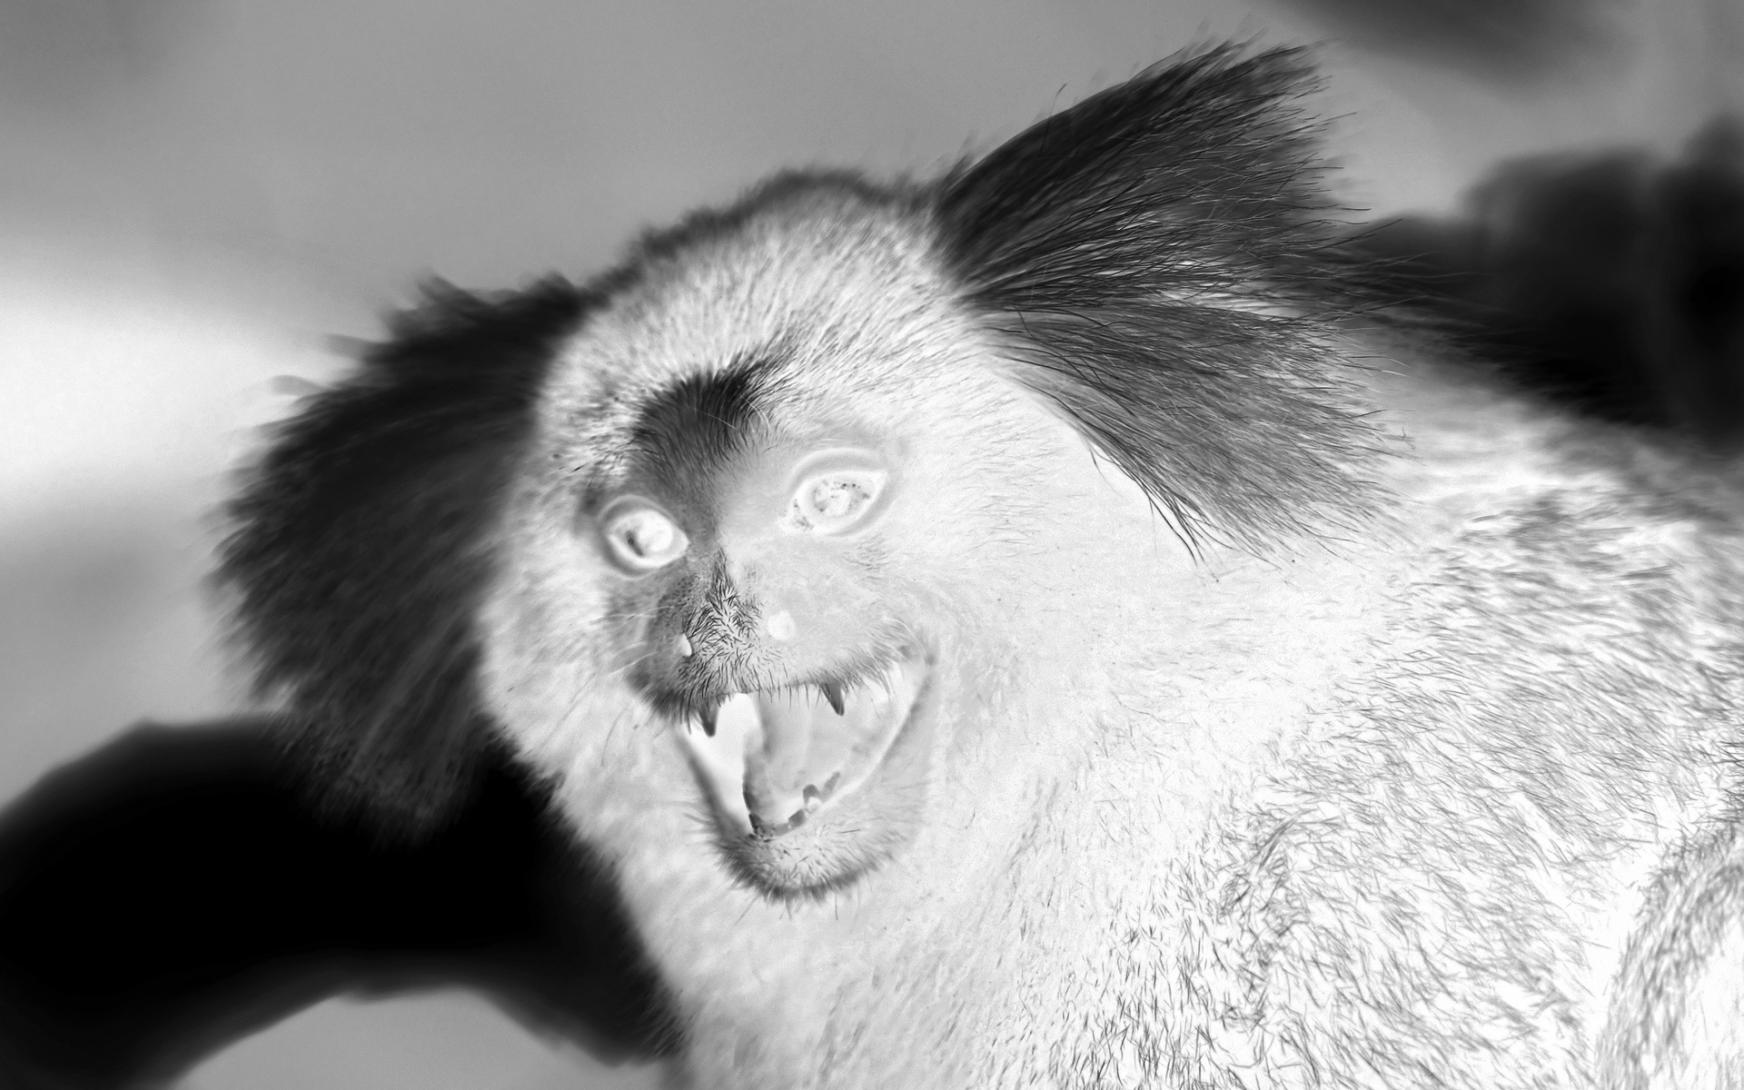 | 

